The Training of Making HMI SCADA using Python and QML Programming integrated to Outseal PLC
Muhammad Husni¹, Eko Budi Utomo², Diky Zakaria³
PT Syergie Indoprima, Jl Gelap Nyawang no 4, Bandung
Politeknik Elektronika Negeri Surabaya, Prodi Teknik Mekatronika
Universitas Pendidikan Indonesia, Prodi Mekatronika dan Kecerdasan Buatan
husnimuttaqin777@gmail.com

Abstract— This research aims to develop an HMI SCADA system using Python and QML programming languages that are integrated with Outseal PLC at PENS Surabaya. The training method used is a project-based training with a focus on SCADA application development. Participants are taught how to create a user interface (HMI) using QML, communicate between HMI and PLC using the Modbus protocol, and integrate Python code with QML. The results of this training show that the participants are able to create a simple SCADA system that is connected to Outseal PLC. The developed system can monitor the input and output status on the PLC and can send control signals to the PLC. This training is expected to provide a better understanding of SCADA system development and improve participants' technical skills in using Python and QML programming languages.

Keywords— Python, QML, MODBUS, HMI, Scada
- Introduction
In recent years, Supervisory Control and Data Acquisition (SCADA) systems have become an essential component of many sectors. These systems are used to monitor and regulate numerous processes, making operations more efficient and effective. The Human-Machine Interface (HMI) is a critical component of SCADA systems because it provides users with a visual representation of the monitored data and allows them to interact with the system. Because of their versatility, ease of use, and availability of open-source libraries, programming languages such as Python and QML have become more popular for the construction of HMI SCADA systems. The goal of this project is to create an HMI SCADA system at PENS Surabaya by integrating Python and QML programming languages with Outseal PLC.

Python is a free, open-source programming language that may operate on a variety of platforms (including Windows, Linux/Unix, and Mac OS X). As a result, Python encourages the development and dissemination of opensource applications. [1]

PLCs (programmable logic controllers) are a subset of embedded systems that are used to control machines and processes. They were first used in the early 1970s to replace the current relay control logic, which had become outmoded and costly for system implementation at the time. PLCs, on the other hand, have provided greater flexibility, higher dependability, improved communication capabilities, faster reaction time, and simplified troubleshooting. PLCs have always been of interest to industrial control engineers who have created, developed, and standardized their own design techniques and programming languages. [2]

SCADA (Supervisory Control and Data Acquisition) systems are technically described as systems that allow for the acquisition of data from remote places as well as supervisory control over different choices that must be made based on the acquired data. SCADA combines data acquisition and telemetry to include information gathering, transfer to a central location, critical control and analysis, and information presentation on screens and displays for operators and decision makers.[3]

Modbus is an open protocol standard that is extensively used in industrial equipment and is utilized in monitoring and control applications. For communication, some Modbus compliant devices feature an RS-485 asynchronous serial interface. Modbus devices and applications are simpler and less expensive than in other industrial networks due to the minimal complexity of the hardware and software required for the protocol's stack. [4]

The integration of the open-source Python programming language as an HMI/SCADA system to communicate with the Outseal PLC has been investigated throughout this article. We were able to effectively design a bespoke HMI/SCADA system that fit the needs of our application by using Python's adaptability. The use of Python in this system not only increased functionality but also provided the advantages of open-source software. Overall, using Python as an HMI/SCADA system was a practical and efficient choice for our application.

- Methods

  - Stage of Preparation
The team reviewed technical matters such as participant target, guiding module, needed components, wiring components, and room preparation throughout the preparation stage.

  - Stage of Implementation
The team engaged in instructional activities with the participants as they attempted to implement the guide module to create the GUI. If people were having problems, the staff would assist them before proceeding with the presentation.

  - Stage of Evaluation
The team evaluated whether or not the individual had completed the specified step at each stage. Following the completion of the material and practical.

These methods are based on previous research from REKA ELKOMIKA: Jurnal Pengabdian Kepada Masyarakat, 2. [5]

- Result and Discussion

Numerous rating methods for programming languages have regularly ranked Python as one of the most popular programming languages. Python also has the capacity to handle a variety of programming paradigms [6]. As a result, we strive to offer a fresh viewpoint on how Python programming may be used to construct HMI SCADA systems in structured training.

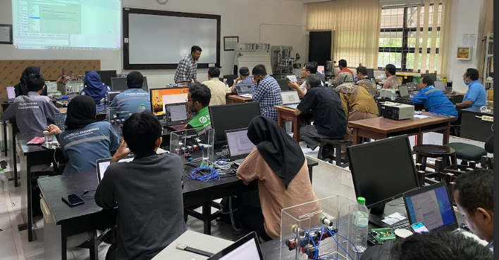
Figure.1 Photo during the training session
The session begins with an introduction of the speaker, followed by ice breaking and the installation of essential software and libraries. Outseal Studio, Notepad++, and Thonny IDE are all essential programming IDE. PyQT5, PyQtCharts and Pymodbus version 2.3.0 are the needed Python libraries.

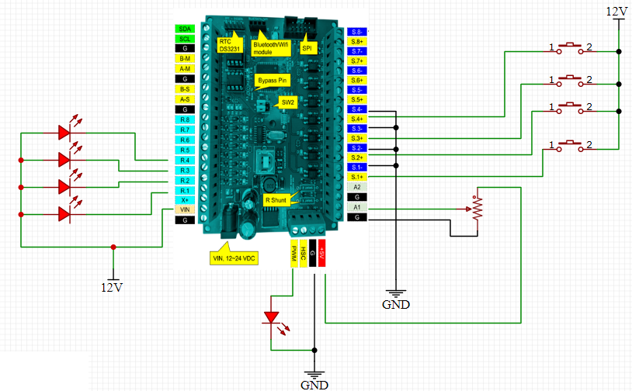
Figure.2 Outseal Wiring
The wiring will be created in the following training session. Outseal hardware, a power supply, an LED, a potentiometer, and a button are all essential components. This course covers the fundamentals of I/O, which includes both analog and digital inputs and outputs that are linked from Python to the PLC using the Modbus RTU communication protocol.

The programming session comes after the wiring session. Ladder programming, Python programming, and QML programming are all part of the programming session. The programming session's outputs include Page 1, which displays digital input and output, Page 2, which displays analog input and output, and Page 3, which displays an analog input and output graph.

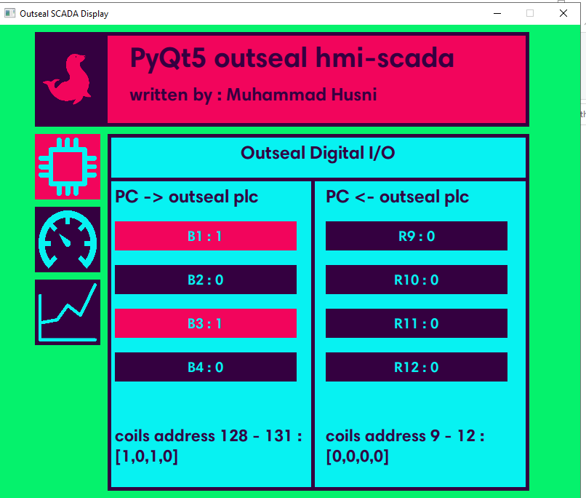
Figure.3 First page of example code : digital I/O

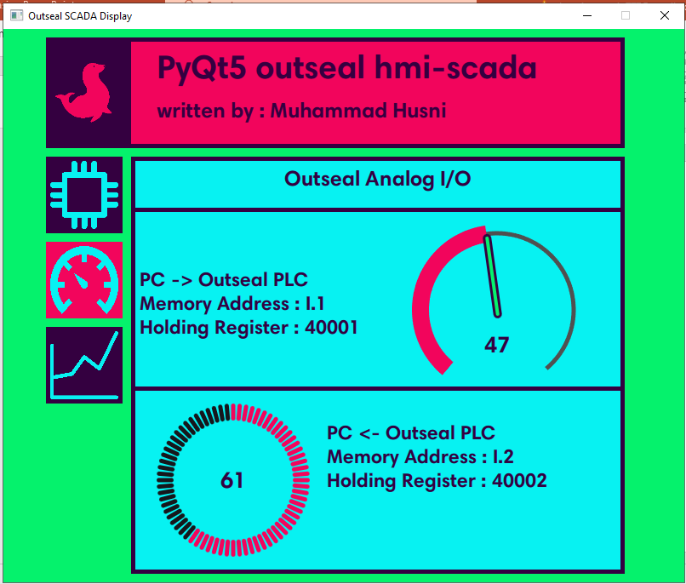
Figure.4 First page of example code : analog I/O

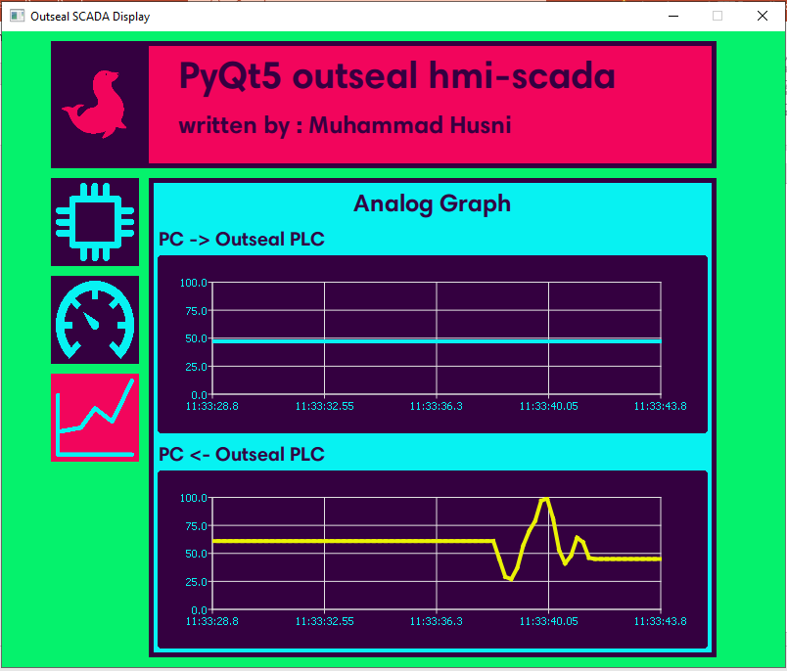
Figure.5 Third page of example code : analog I/O graph

The software works by using QML for the display, Python for the process, and the PLC ladder program for input/output to the PLC. Python and QML are linked together with pyqtSlot, while Python and the PLC ladder program are linked by Pymodbus.

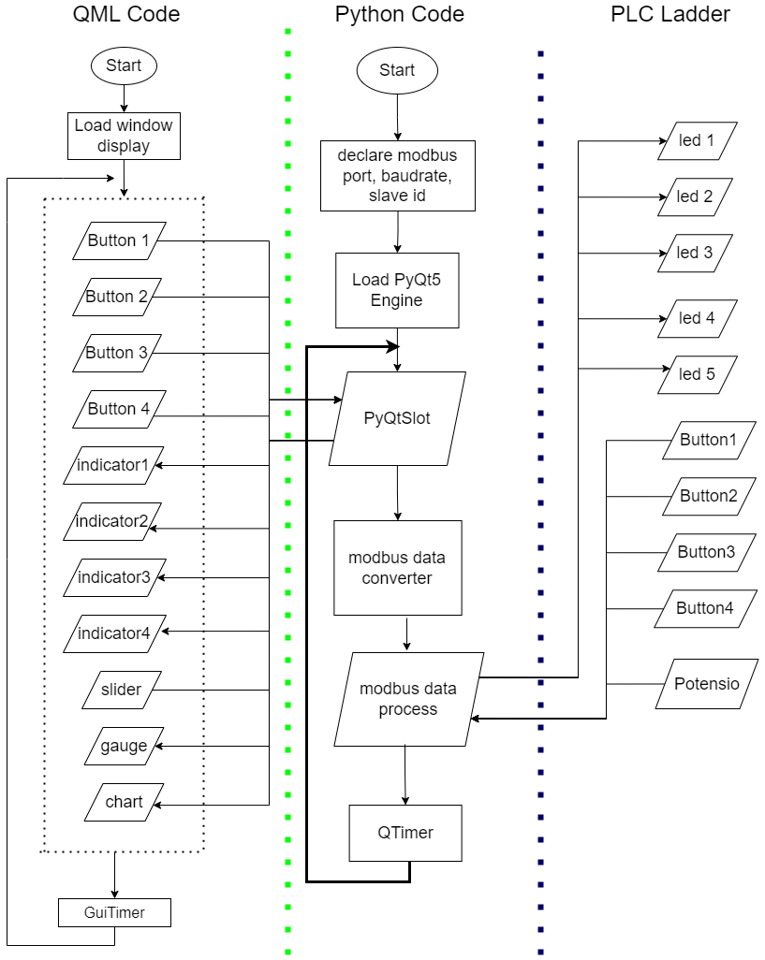

Figure.6 Flowchart of HMI SCADA Python system
The Python HMI SCADA flowchart depicts the steps involved in developing a graphical user interface (GUI) for SCADA systems using the Python programming language. This flowchart can help you understand how to build a SCADA system and how Python can be used to create the necessary components.

No | Questionaries | Scores
No | Questionaries | 1 | 2 | 3 | 4 | 5
1 | Participants were able to understand the material | 0% | 0% | 8.3% | 50% | 42%
2 | This workshop was very useful in supporting my career or job. | 0% | 0% | 0% | 54% | 46%
3 | This workshop is very relevant to the real-time problems I face at work. | 0% | 4.2% | 12.5% | 62.5% | 20.8%
4 | This workshop taught me to analyze problems and find solutions. | 4.2% | 0% | 12.5% | 50% | 33.3%
5 | The instructor mastered the material presented. | 0% | 0% | 0% | 58% | 41.6%
6 | This workshop was delivered in a good systematic way. | 0% | 0% | 12.5% | 42% | 46%
7 | Supporting facilities such as equipment, rooms, and other technical aspects were very good. | 0% | 0% | 12.5% | 50% | 37.5%
8 | The instructor was sensitive to difficulties experienced by participants. | 0% | 0% | 0 | 46% | 54%
9 | Teamwork and learning efficiency in this workshop were very good. | 0% | 0% | 8.3% | 46% | 46%

Following the completion of the training session, an evaluation session was held. 25 participants completed a questionnaire regarding the training, including questions about the subject presented and the course's relevance for their jobs. The participant questionnaire results are appended in the table below.
- Conclusions
Python is a popular programming language that is commonly utilized by technology businesses to construct apps. A Python introduction is required for students and teachers to adapt to technological advances, particularly in the fields of Human Machine Interface (HMI) and Supervisory Control and Data Acquisition (SCADA). The goal of this community service project was to introduce Python programming for HMI/SCADA systems and its interface with hardware. Overall, participants performed well in this exercise and were pleased with the instruction. Few participant assessments were attributed to the training being conducted in only one meeting. Nonetheless, participants were happy and eager to learn more about Python by using the modules offered.
Acknowledgment
This Training activity is funded by PENS Surabaya
References
- Fernandes, Thiago R. ; Fernandes, Leonardo R. ; Ricciardi, Tiago R. ; Ugarte, Luis F. & de Almeida, Madson C.. (2018). Python Programming Language for Power System Analysis Education and Research. 2018 IEEE PES Transmission & Distribution Conference and Exhibition - Latin America (T&D-LA)
- Pratumsuwan, Pornjit and Pongaen, Watcharin. (2011). An Embedded PLC Development for Teaching in Mechatronics Education. 2011 6th IEEE Conference on Industrial Electronics and Applications
- Abdi, Syed Umer; Iqbal, Kamran; & Ahmed, Jameel. (2016). Development of PC-based SCADA training system. 2016 IEEE International Conference on Industrial Technology (ICIT)
- Künzel, Gustavo; Ribeiro, Matheus Antônio Corrêa; Pereira, Carlos Eduardo. (2014). A Tool for Response Time and Schedulability Analysis in Modbus Serial Communications. 2014 12th IEEE International Conference on Industrial Informatics (INDIN)
- Al Maududi, R., Putri, R. W., & Hartuti, P. M. (2021). GeoGebra Training for Making Mathematics Learning Media at SMPN 11 Depok. REKA ELKOMIKA: Jurnal Pengabdian Kepada Masyarakat, 2(2), 67–74. https://doi.org/10.26760/rekaelkomika.v2i2.67-74
- Wang, Chaoyi; Vemula, Srikanth; and Frye, Michael. (2020). Out-of-school Time STEM: Teach Programming Using Python for High School Girls. 2020 IEEE Integrated STEM Education Conference (ISEC)

